

**The University of Lahore**

*Faculty of Information Technology*

|  |
| --- |
| **Assignment Cover Letter**  *(Individual Work)* |

|  |  |  |  |
| --- | --- | --- | --- |
| Student Name | Atta Elahi | Program | BS(SE) |
| SAP ID | 70082385 | Title of Assignment | 03 |
| Course Code | CS 11303 | Due Date | 26/12/2022 |
| Course Name | Operating Systems | Submission Date | 26/12/2022 |
| Section | T |

**The assignment should meet the below requirements:**

1. Assignment (hard copy) is required to be submitted on clean paper and soft copy as per lecturer’s instructions.
2. Soft copy assignment also requires the signed (hardcopy) submission of this form, which automatically validates the softcopy submission.
3. The above information is complete and legible.
4. Compiles pages are firmly attached.
5. Assignment has been copied (softcopy & hardcopy) for each student ahead of the submission.

**Plagiarism/Cheating**

The university seriously regards all forms of plagiarism, cheating and collision as academic offenses which may result in severe penalties, including loss/drop of marks, course/class discontinuity and other possible penalties executed by the University.

**Declaration of Originality**

By signing this assignment, I understand, accept and consent to The University of Lahore terms and policies on plagiarism.

I hereby declare that this work represents my own effort, and that all text and code have been written by me and has not been submitted for the use of assessment in another course or class, except where this has been notified and accepted in advance.

|  |  |
| --- | --- |
| *Signature* |  |

**Question-1**

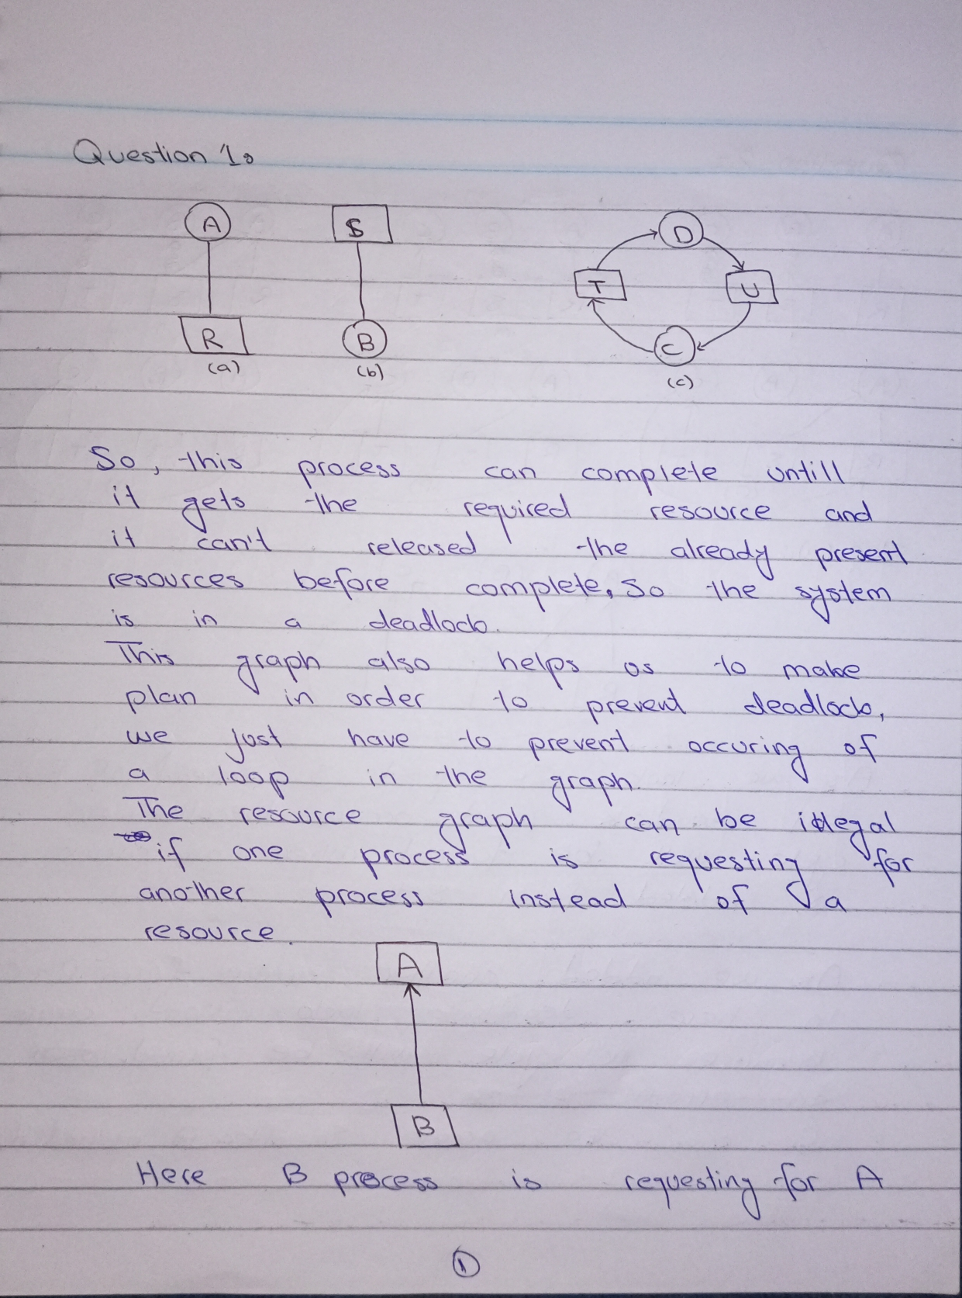

**Question-2**

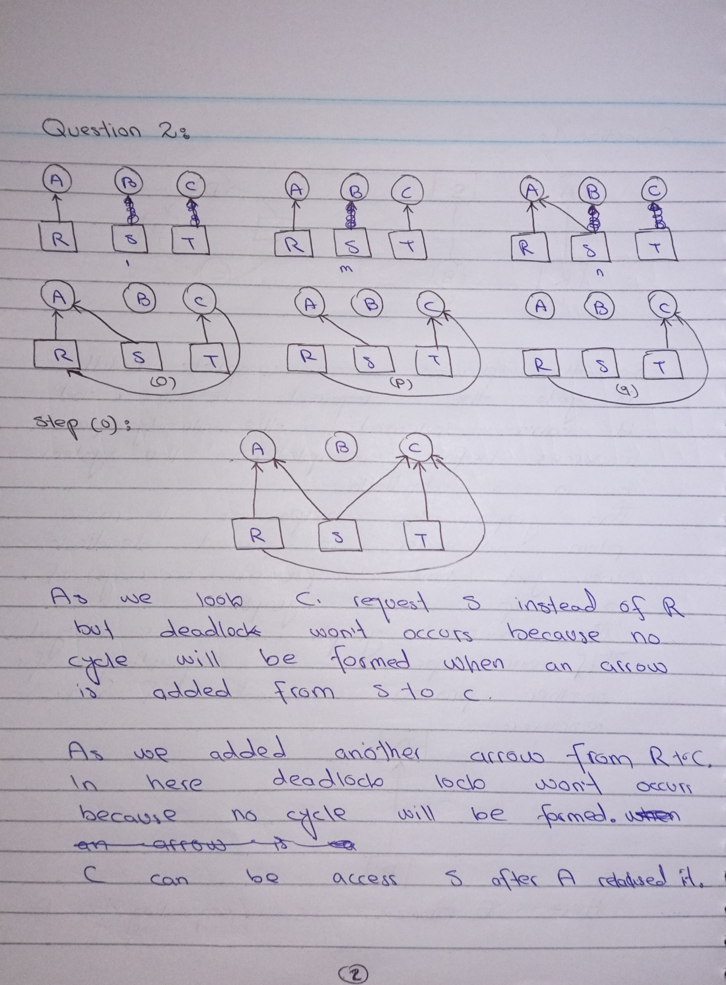

**Question-3**

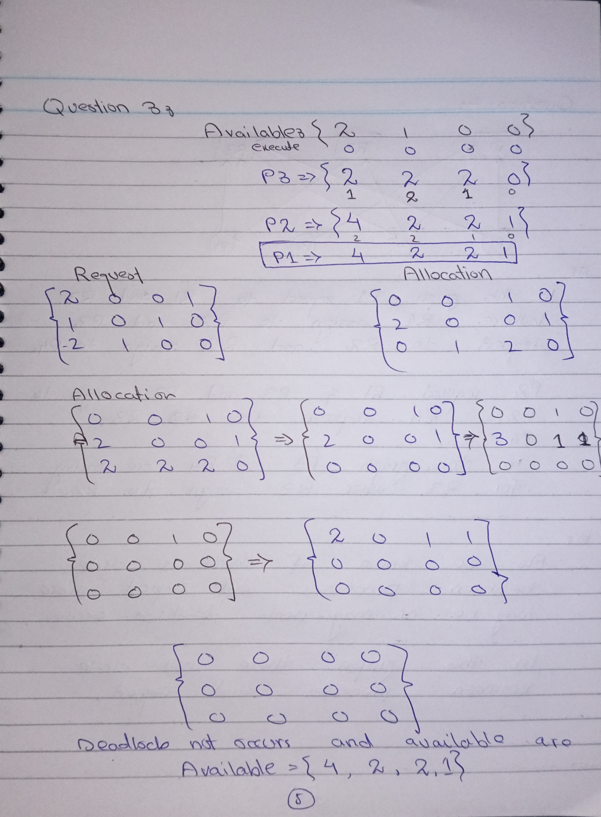

**Question-4**

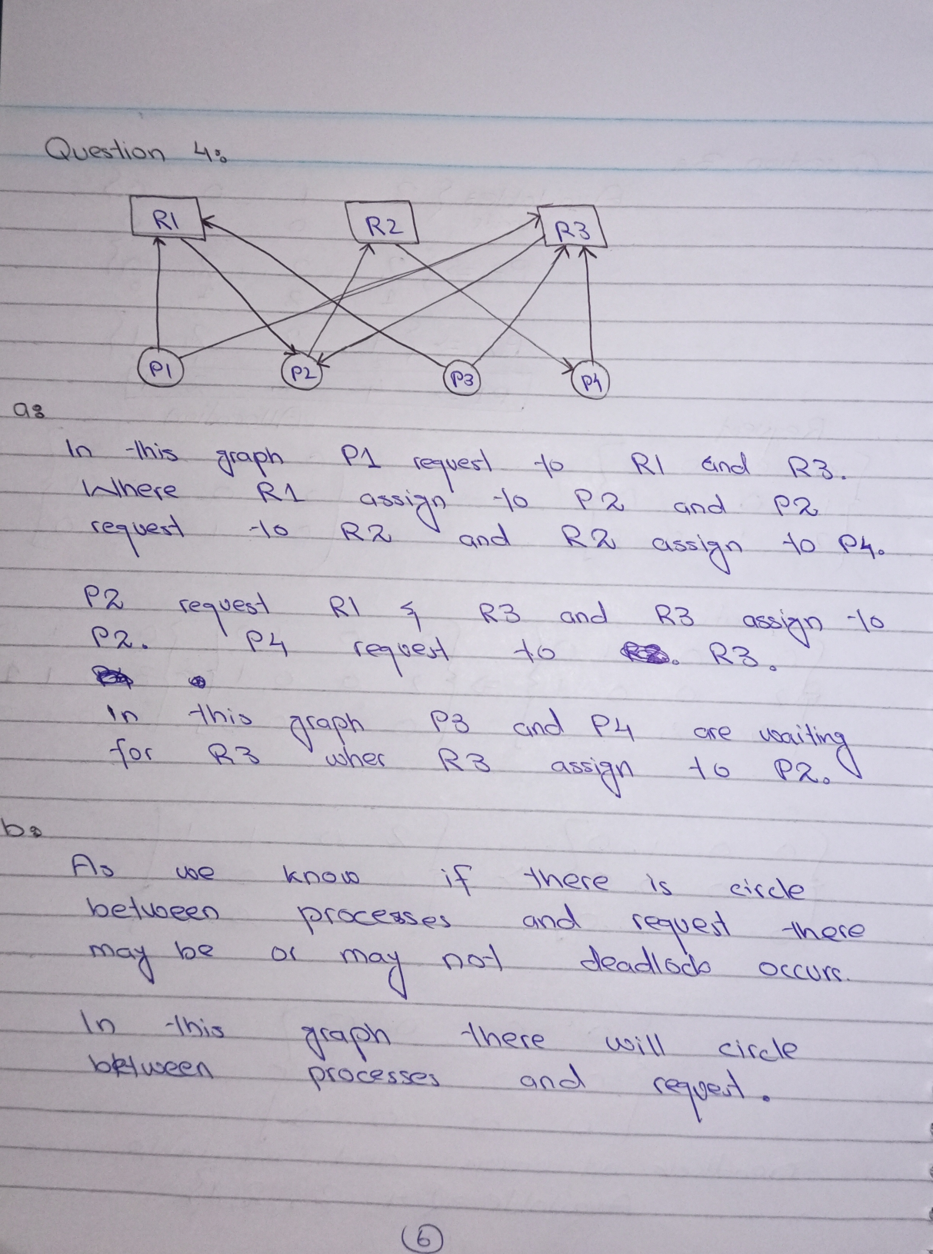

**Question-5**

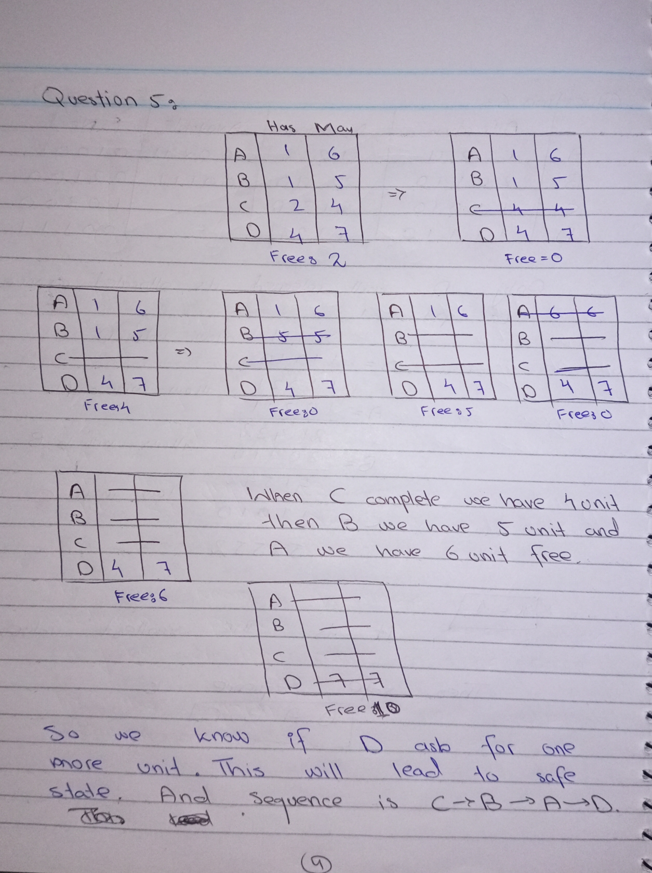

**Question-6**

